**10.AWS-EC2-Part2-MetaData-LaunchTemplates & Spot Instances**

**EC2- SERVER INFORMATION**

--- **ec2-metadata** – this command will give you all the information on the server. This information comes from metadata. Every instance has LINUX or windows metadata. We can access this metadata by using below command.

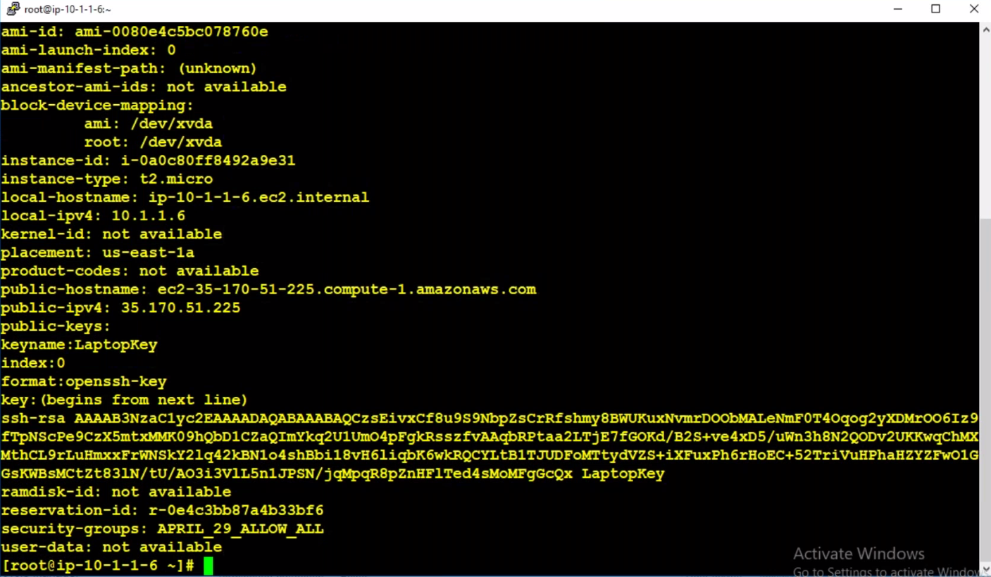

--- **curl** [**http://169.254.169.254/latest/meta-data/**](http://169.254.169.254/latest/meta-data/) - this is fixed IP address for every server. This is private ip, only internal use.

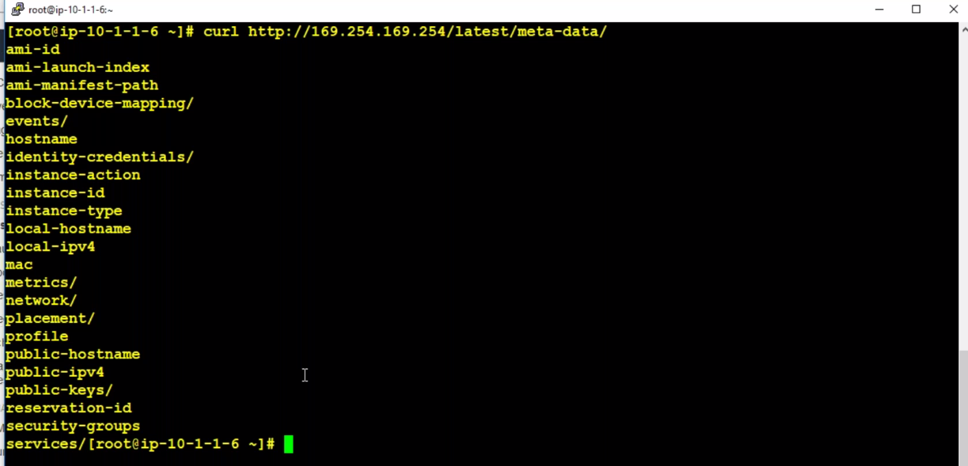

--- we can use them as a variable to access the information. Like below.

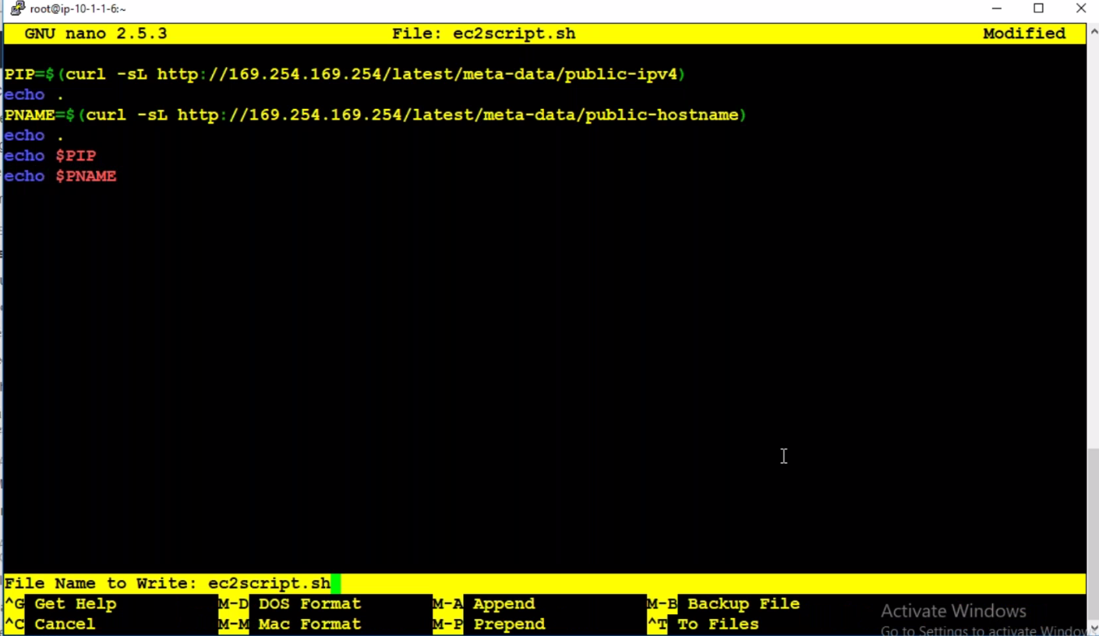

--- **chmod 700 ec2script.sh –** permission to execute.

--- **./ec2script.sh** – script executing command.

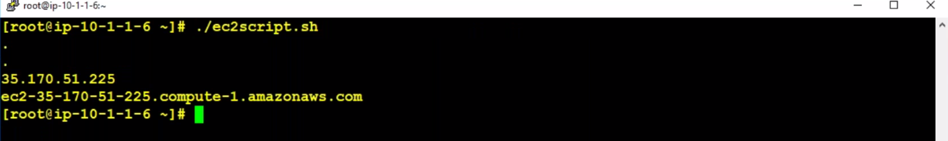

--- here I wrote a script for accessing variables and execute the script.

**Launch Templates**

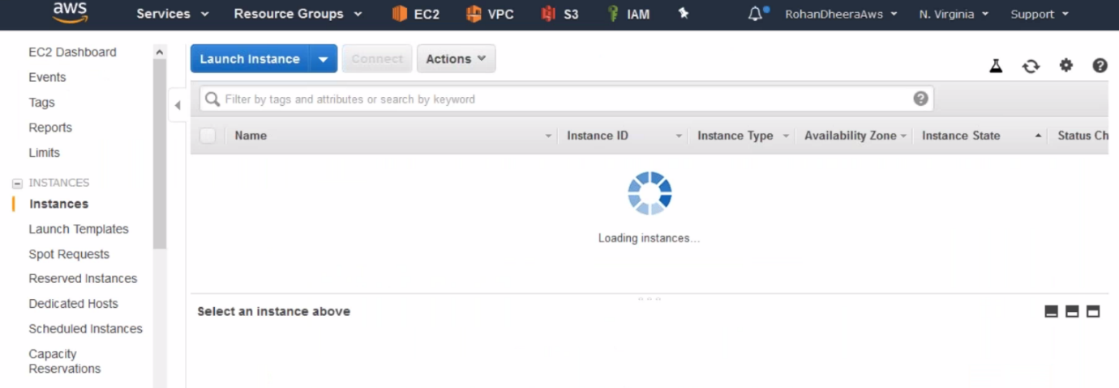

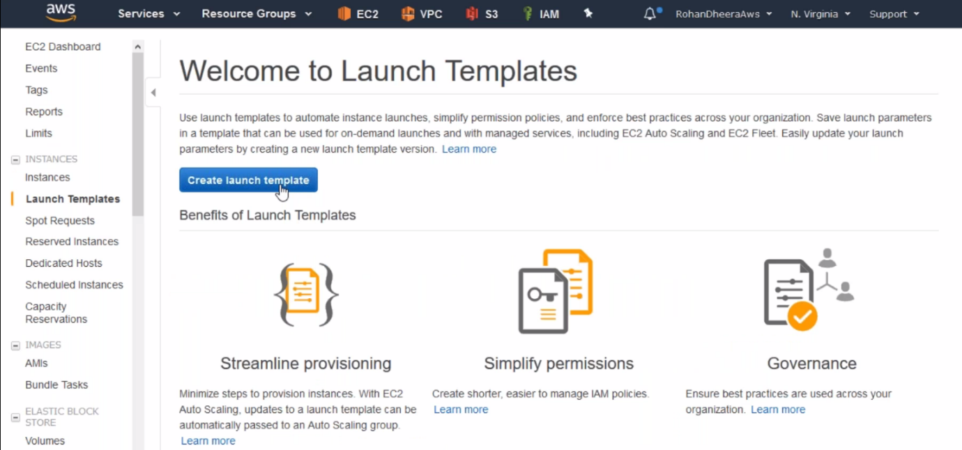

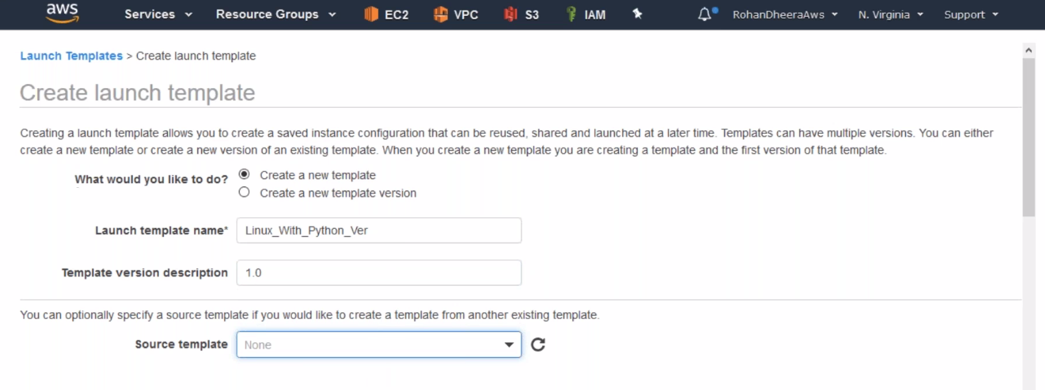

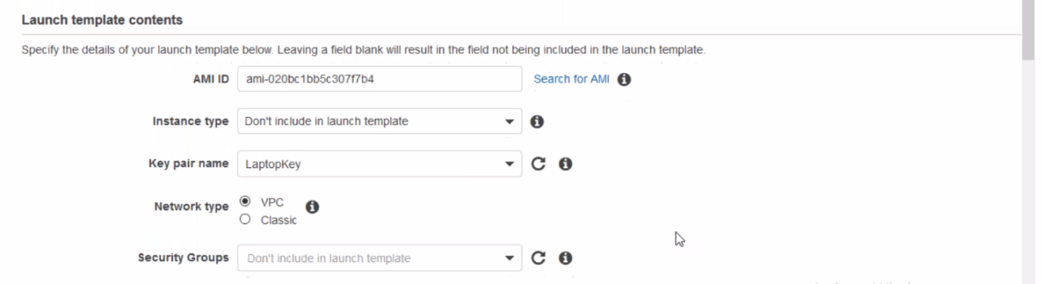

--- leave the instance type because developer will select the instance type, and select the security group

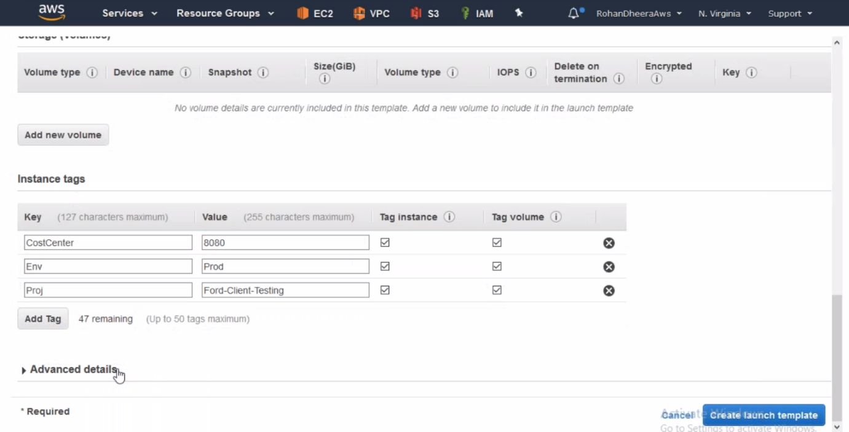

**Launching instance from template**

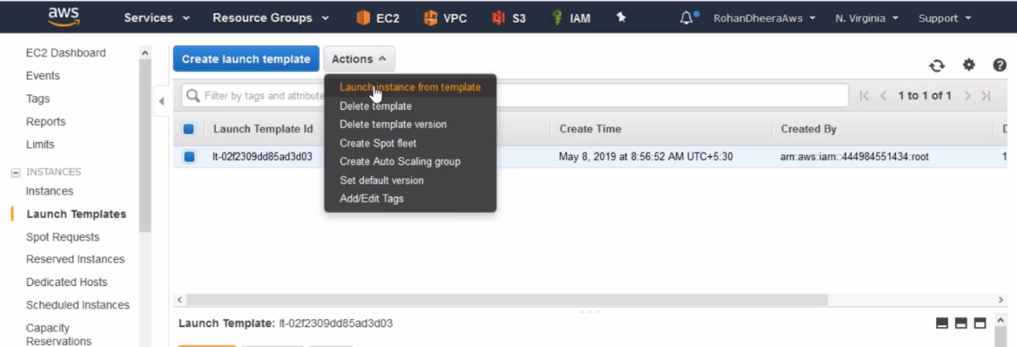

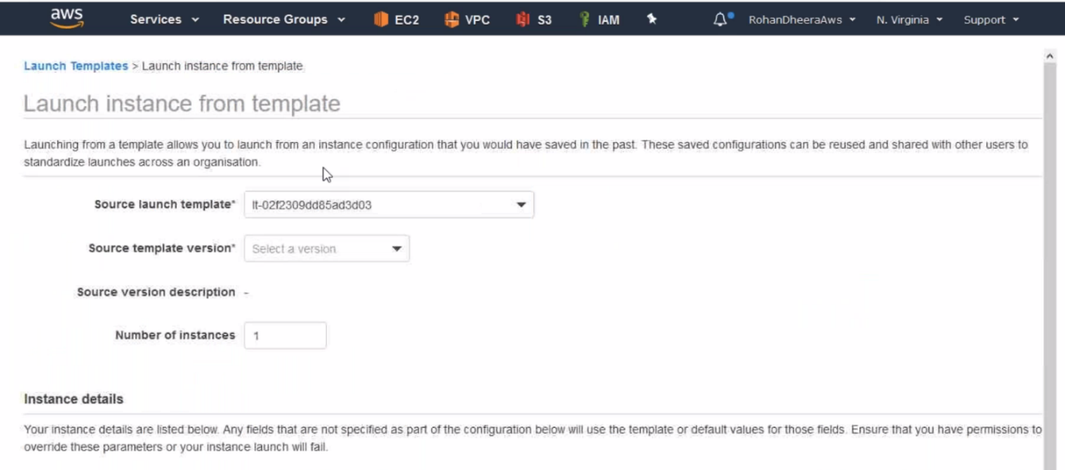

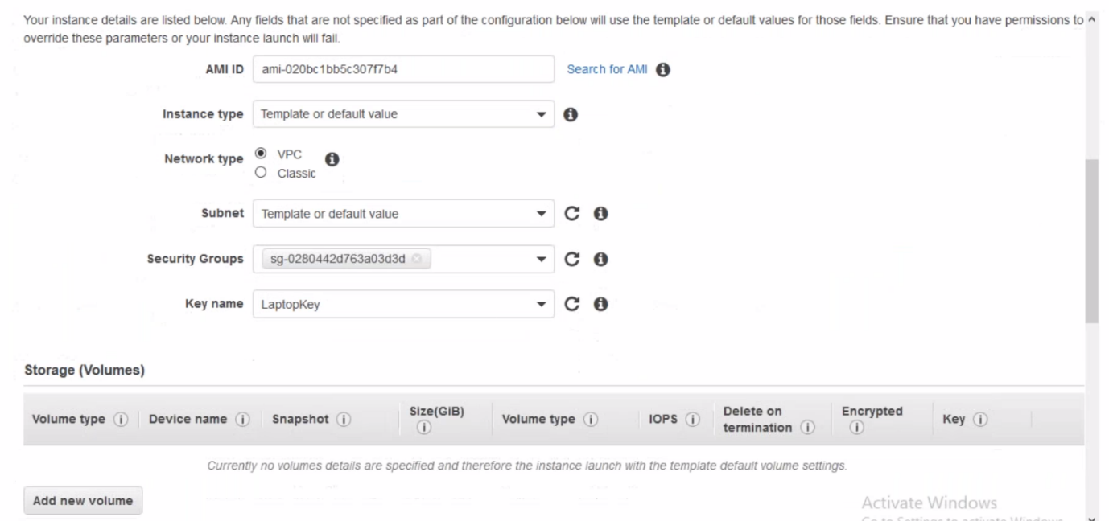

**Spot Instances**

You will get instances for very less price compared to the on demanded instances

--- **QUES how we will get spot instance for very cheap price…?**

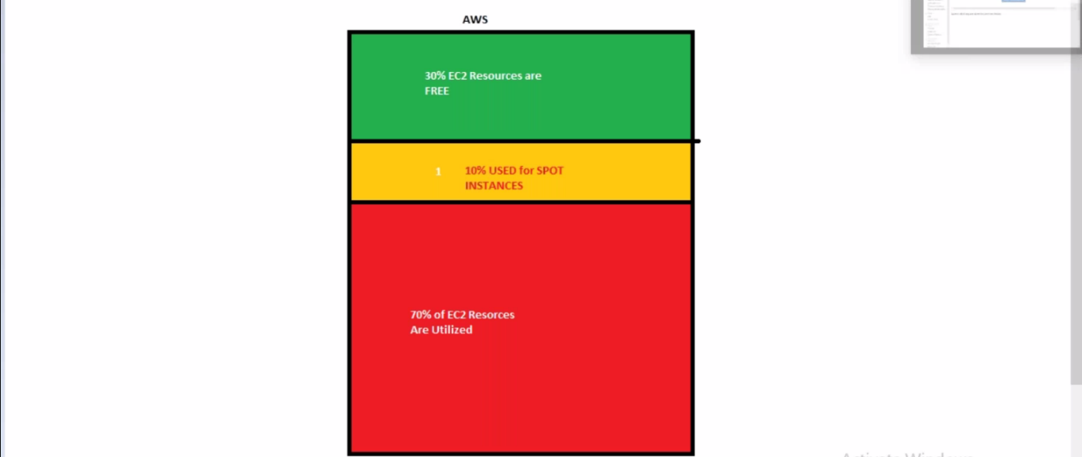

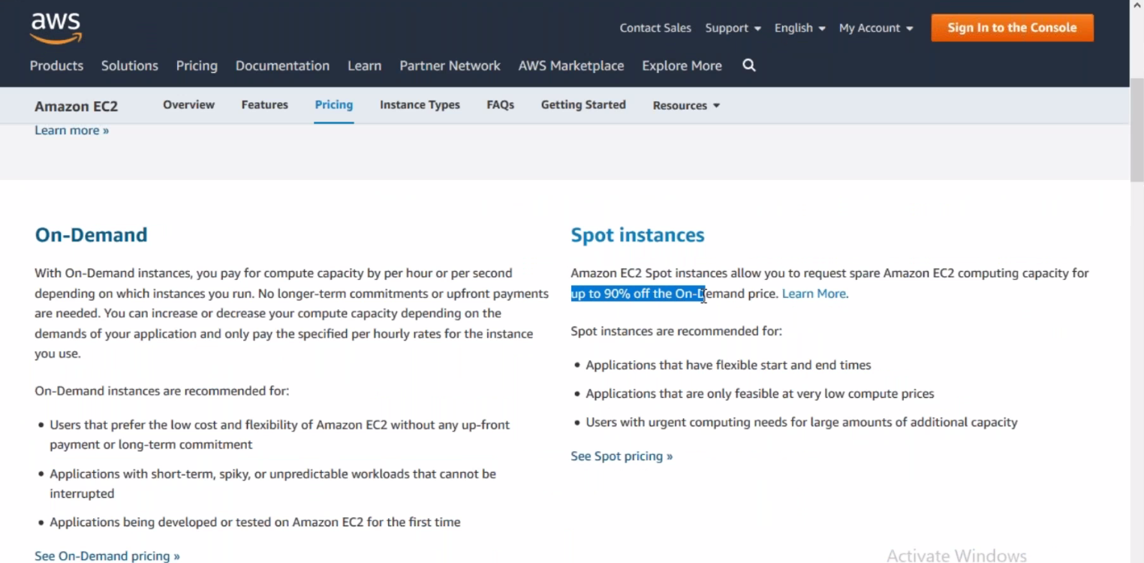

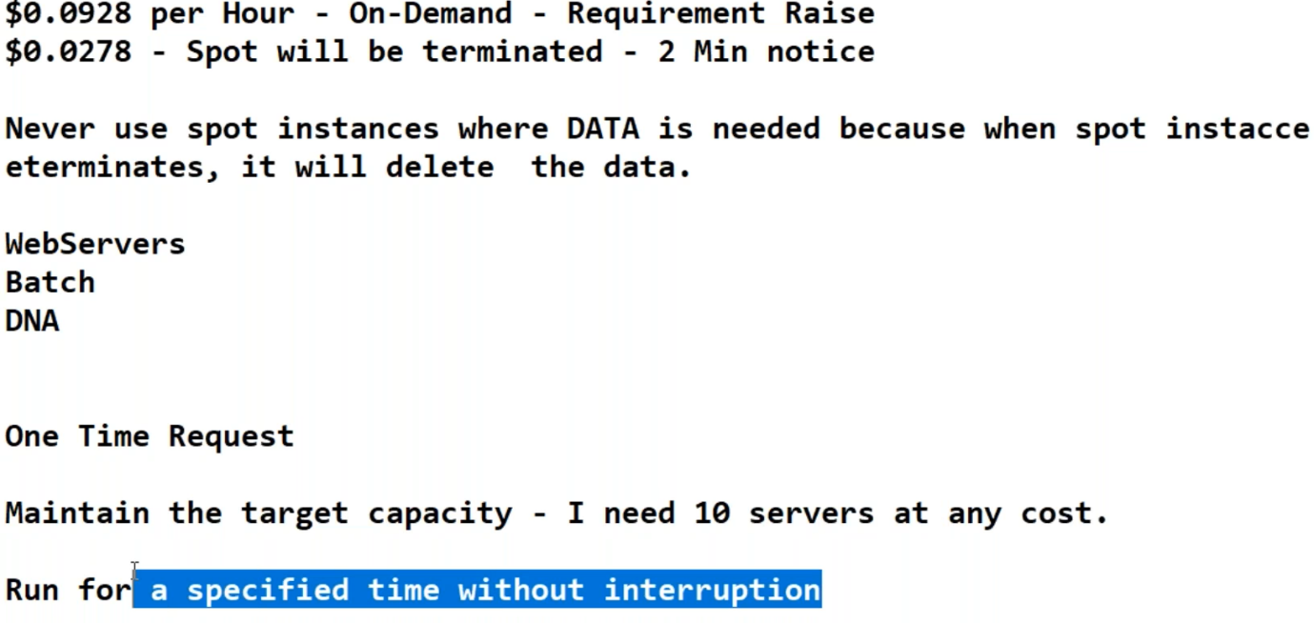

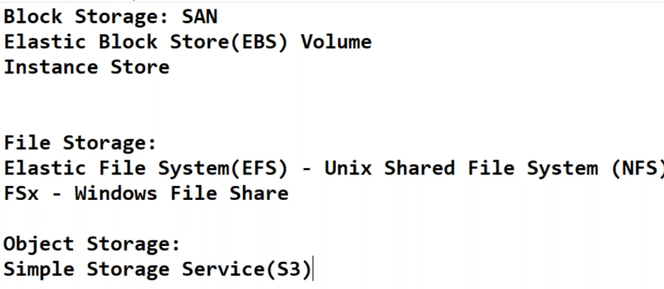

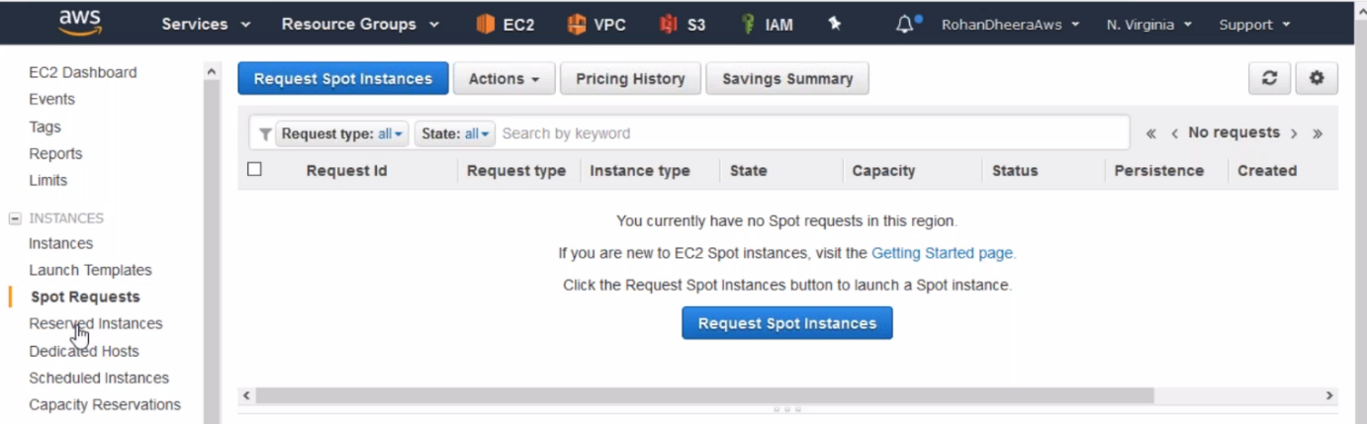

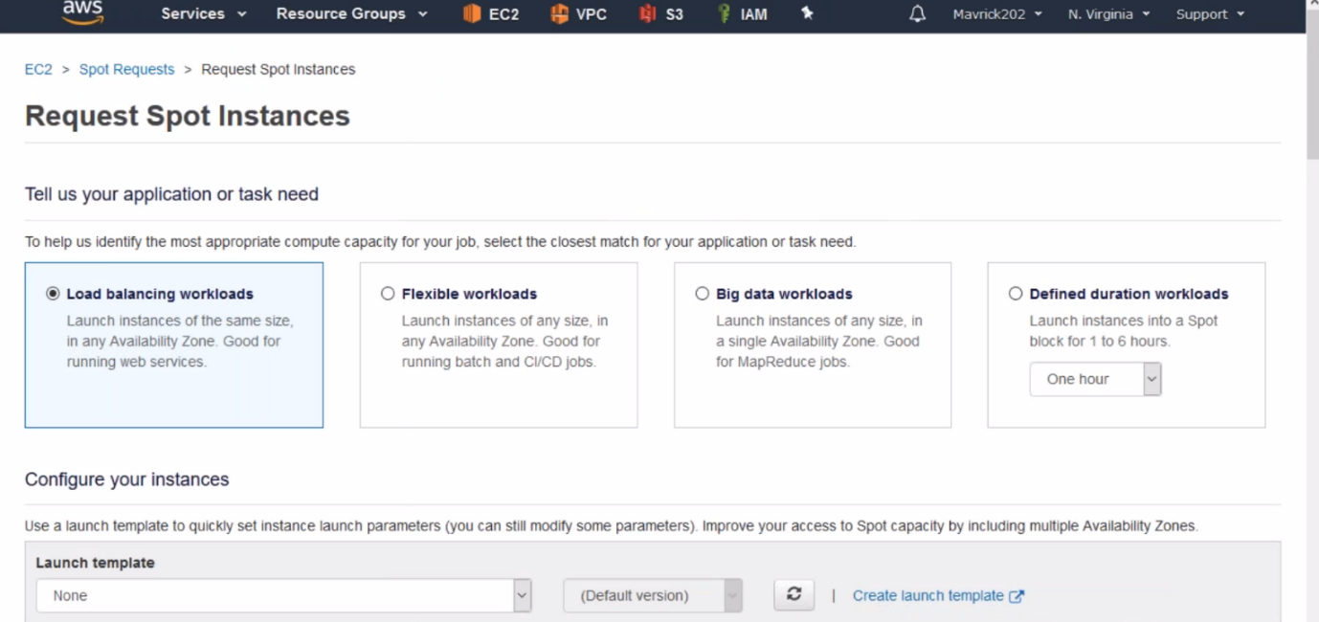

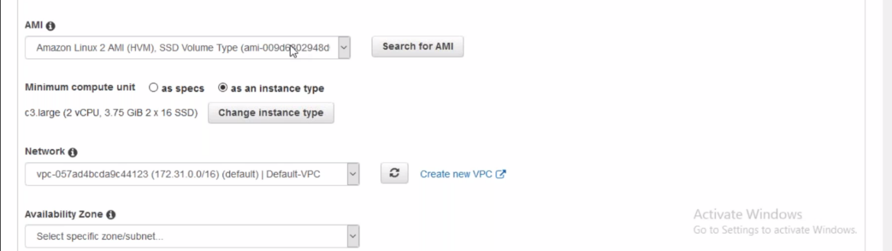

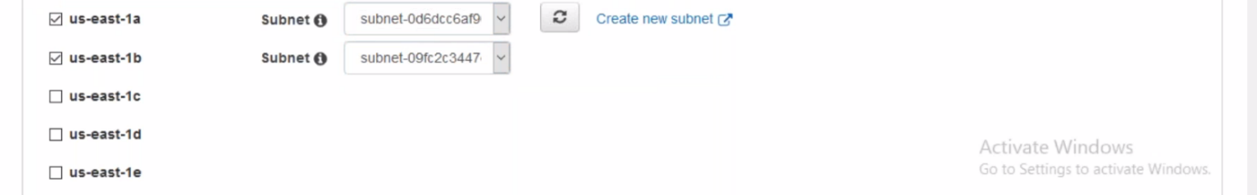

**Spot instance limit increasing**

